Lanark Lodge

Community Newsletter

December 2022

Merry Christmas
From our family here at Lanark Lodge to yours we are wishing everyone a happy and healthy Christmas season.

Outbreak Status
As I am sure you are aware Maples & Honeysuckle Neighbourhoods are experiencing a COVID 19 outbreak. Reminder to families and visitors to be vigilant with your hand hygiene, masking, and PPE if you are required to wear it.
Taste Like Home Initiative
Congratulations to Ken Blair who is this month’s winner. The Blair Family Christmas Stuffing. This recipe will be featured at our Christmas Dinner on December 25th. Each month the winner will get to have their recipe posted throughout the home on the bulletin boards, and then if they would like a tour of our kitchen facilities. Our Dietary manager will take the winner down to the kitchen where they will meet all our wonderful dietary staff and see how their meals are prepared. If you would like to help your loved one submit a recipe, feel free to do so. Cindy McCall our dietary manager is keeping all the recipes and we hope to create a recipe book called Taste of Home, which we will have for sale as a fundraiser. Stay tuned for more information as to when we have enough recipes to complete the book.
Here is Ken’s Recipe for anyone wanting to make it at home.

Blair Family Christmas Stuffing

3 loaves of bread plucked fine in a big bowl
Sautee 7 onions chopped fine and 2lb butter
Add poultry seasoning, salt & pepper to taste.

Then work it into the bread.
Add water or turkey juice and mayonnaise to make it moist.

Below is a photo of last month’s winner Mr. Ed Spencer.

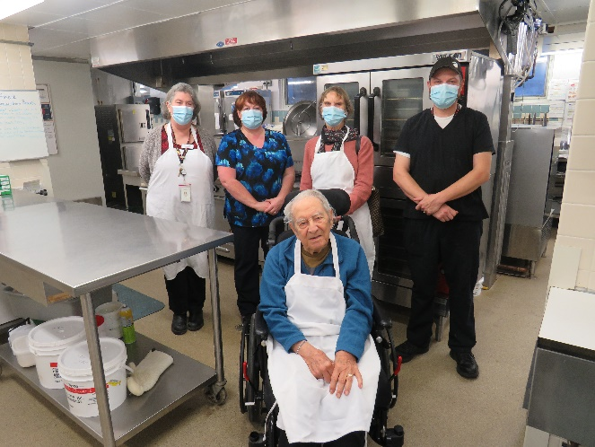

Footcare
Effective January 1st, 2023, we will be resuming the invoicing for footcare services. This service will be processed from the trust account. If you have signed up for footcare services, please stop in at the office at your earliest convenience and sign the authorization form to have footcare charges withdrawn from the account. You will be responsible to pay the provider for any services provided prior to January 1st, 2023. If you have any questions regarding this change, please contact Annette at X 7104.

Family Council
Lanark Lodge Council of Family and Friends meet Virtually every second Thursday. You can reach council at llfamilycouncil@gmail.com

